TITLE: SHOULD BE CONCISE AND INFORMATIVE, AVOIDING ABBREVIATIONS AND FORMULAE

SUBTITLE: CONCISE AND INFORMATIVE

Abstract
In English only, up to 200 words. A concise and factual abstract is required. The abstract should briefly state the purpose of the research, the principal results, and major conclusions. An abstract is often presented separately from the article, so it must be able to stand alone. For this reason, References should be avoided. Non-standard or uncommon abbreviations should be avoided, but if essential they must be defined at their first mention in the abstract itself.

Keywords
keyword 1, keyword 2, keyword 3, keyword 4, keyword, 5 keyword 6, keyword 7, keyword 8.

Immediately after the abstract, provide a maximum of 8 keywords. Keywords should clearly cover the factual, spatial, temporal, and methodological scope of contribution, and avoiding general and plural terms and multiple concepts These keywords will be used for indexing purposes.

INTRODUCTION
Clearly outline the objectives of the work and furnish a sufficient background, refraining from an extensive literature survey or summarizing the results.

THEORETICAL FRAMEWORK (optional)
The Theory section should expand upon, rather than duplicate, the background covered in the Introduction. Its purpose is to establish the groundwork for subsequent research.

MATERIAL AND METHODS
Offer comprehensive details to enable independent replication of the work. Summarize methods that are already published, providing references. If directly quoting from a previously published method, use quotation marks and cite the source. Describe any modifications made to existing methods.

RESULTS
Results should be clear and concise.

DISCUSSION
This should explore the significance of the results of the work, not repeat them. A combined Results and Discussion section is often appropriate. Avoid extensive citations and discussion of published literature.

CONCLUSIONS
Present the primary conclusions of the study in a concise Conclusions section, which can either stand alone or be incorporated as a subsection within the Discussion or Results and Discussion section.

SUMMARY
The summary will be compact, containing the aim, methods, and main results of the article. It will not contain statements and knowledge not included in the prime text. The submitted text of the Summary in English will be translated into Slovak for English-written articles.

REFERENCES
Ensure that every reference mentioned in the text is also included in the reference list, and vice versa. Avoid listing unpublished results and personal communications in the reference list, but they may be referenced in the text. If included in the reference list, follow the standard format of the Journal, substituting the publication date with either 'Unpublished results' or 'Personal communication.' When citing a reference as 'in press,' it indicates the item has been accepted for publication. Utilize DOIs whenever possible, as their use is highly encouraged. Adhere to the Harvard system of references, ensuring that references conform to the specified style. For examples, refer to the end of this template.

Please do not quote ACKNOWLEDGEMENT in manuscript. If it is necessary, describe details in Title Page

Recommended extent of the manuscript is 21 000 - 36 000 characters including references, text and graphic appendixes, and notes. Articles exceeding this standard will be required to be shortened to the recommended extent.

The manuscript must be delivered in electronic form (MS Word or OpenOffice Writer formats). If possible, use fonts like Poppins, Arial, Courier, Times New Roman or similar alternatives. The pages and lines must be numbered.

Modify the name of manuscript file, so it does not contain information enabling the identification of authors. Sanitize document (and its properties) to ensure the removal of author details.
Equations:
Ensure that mathematical equations are presented as editable text rather than images. Integrate simple formulas into the normal text when possible, using the solidus (/) for small fractional terms (e.g., X/Y). Italicize variables and denote powers of e as exp. Number any equations that are displayed separately from the text consecutively, especially if explicitly referenced in the text.

Artwork:
- Ensure consistent lettering and sizing in your original artwork.
- If possible, embed the fonts used in the application. Opt for fonts like Poppins, Arial, Courier, Times New Roman or similar alternatives.
- Number illustrations according to their sequence in the text.
- Employ a logical naming convention for your artwork files.
- Size the illustrations close to the desired dimensions for the published version.
- Ensure that each illustration has a caption.
- Supply captions separately, not attached to the figure.
- A caption should comprise a brief title (not on the figure itself) and a description of the illustration.
- Keep text in the illustrations themselves to a minimum but explain all symbols and abbreviations used.
- After accepting your manuscript, you will be prompted to submit each illustration / artwork as a separate file.
- Submit tables as editable text, not images.
- Place tables either adjacent to relevant text or on separate page(s) at the end.
- Number tables consecutively based on their appearance in the text, and position any table notes below the table body. Use tables sparingly, avoiding duplication of results elsewhere in the article.
- Refrain from employing vertical rules and shading in table cells.

Formats:
If your electronic artwork is created in a Microsoft Office application (Word, PowerPoint, Excel) then please supply 'as is' in the native document format.
Regardless of the application used other than Microsoft Office, when your electronic artwork is finalized, please 'Save as' or convert the images to one of the following formats (note the resolution requirements for line drawings, halftones, and line/halftone combinations given below):
- EPS (PDF): Vector drawings, embed all used fonts.
- TIFF (PNG, JPEG): Colour or grayscale photographs (halftones), keep to a minimum of 300 dpi.
- TIFF (PNG, JPEG): Bitmapped (pure black & white pixels) line drawings, keep to a minimum of 1000 dpi.
- TIFF (PNG, JPEG): Combinations bitmapped line/halftone (colour or grayscale), keep to a minimum of 500 dpi.
Please do not:
- Supply files that are optimized for screen use (e.g., GIF, BMP, PICT, WPG); these typically have a low number of pixels and limited set of colours.
- Supply files that are too low in resolution.
- Submit graphics that are disproportionately large for the content.

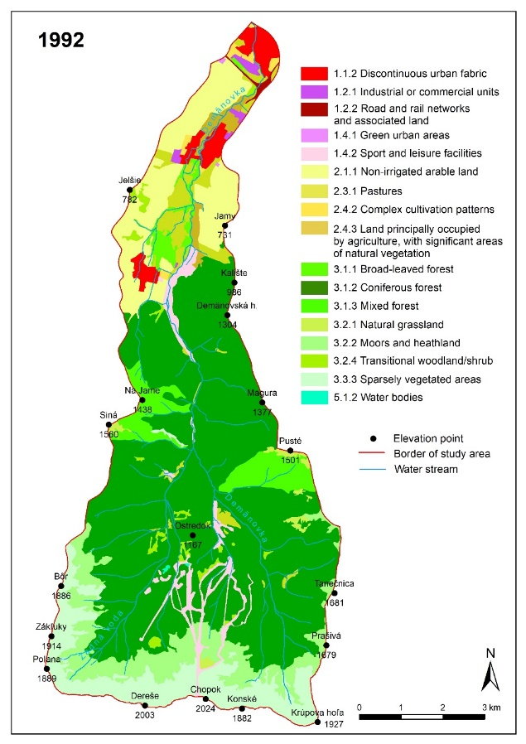
Fig. 1. GIS interpretation of land cover changes of the Demänovská river catchment using the CLC classification in 1992

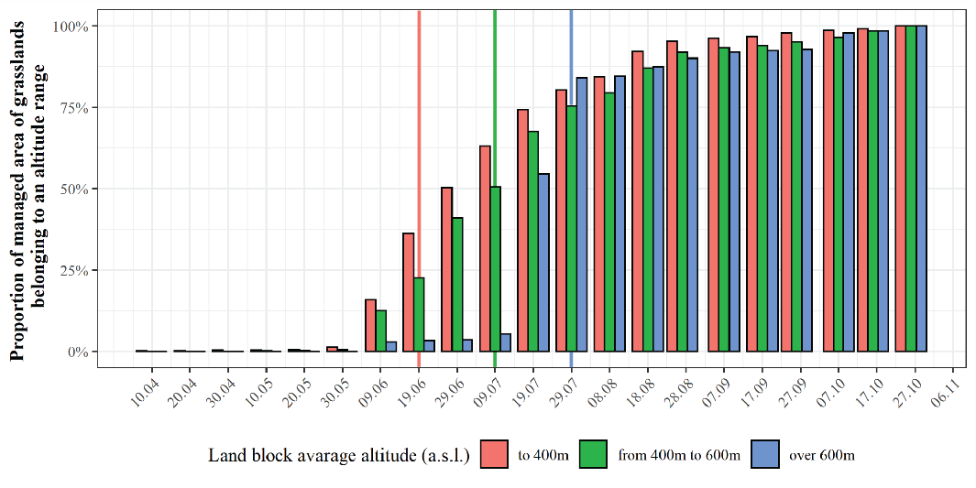
Fig. 2. Dates of the first identified management practice on grasslands. Vertical lines refer to time limits set in government regulation.
Table 1. Table caption.
Economic sectors | Scope of economic activity | Economic activity
LINE 1 | Lowercase text | Lowercase text
LINE 2 | Little bit more text text text text text | Significantly more text text text text text text text text text text
LINE 3 | text text for third row | Lowercase text
Sources: Author 1939; Author 1940; Author 1945; Mallick 2015; Author1 and Author2 2015, Eurostat (2016a).

References (examples):
Act No. 391/2000 Coll. amending and supplementing the Act No. 127/1994 Coll. of the National Council of the Slovak Republic on environmental impact assessment.
BEŇO, M. (2023). What’s new in Slovak Science: ERC grant drought ends. Slovak Spectator, 27 April 2023, [Online], Available: https://spectator.sme.sk/c/23161788/whats-new-in-slovak-science-erc-grant-drought-ends.html
BODNÁR, J. (2001) Fin de millénaire Budapest: Metamorphoses of urban life. Minneapolis (University of Minnesota Press).
BRADSHAW, M., STENNING, A. eds. (2004). East Central Europe and the former Soviet Union. Harlow (Pearson/Prentice Hall).
BUTLER, R.W. (2009). Tourism Destination Development: Cycles and Forces, Myths and Realities. Tourism Recreation Research, 34, (3), 247–254. DOI: https://doi.org/10.1080/02508281.2009.11081600
DE BRUIJN, O. (2002). There is only one forest. In DE BRUIJN, O., KAZULKA, H., OKOŁÓW, C. eds. The Bialowieza Forest in the third millennium: challenges for nature conservation and sustainable development : proceedings of the cross-border conference held in Kamenyuki (Belarus) and Bialowieza (Poland) from 27th to 29th June 2000. Brest (Lavrov S. B.), pp. 15–24.
DZURINDA, M. (2018). Slovakia, still the ‘black hole’ of Europe. Politico. 16 March 2018. [Online], Available: https://www.politico.eu/article/slovakia-black-hole-of-europe/ [accessed 27 July 2023].
EEA (2000). CORINE Land Cover. Copenhagen (European Environmental Agency).
FERANEC, J., OŤAHEĽ, J., ŠÚRI, M. (1995). Application of the CORINE Land Cover Project in the Slovak Republic. In Environment and quality of life in Central Europe: Problems of transition, Conference proceedings. Prague (Albertina Icome and Charles University, Faculty of Science), CD-ROM, record 128/484.
LYCK, L. (2012). Strategy and Framework for Tourism in the Baltic Sea Region Countries: Cultural and Nature Tourism in the Baltic Sea Region Countries. Copenhagen (Copenhagen Business School – Center for Tourism and Cultural Management) [Online], Available: https://research-api.cbs.dk/ws/portalfiles/portal/58852919/Lise_Llyck_4.pdf [accessed 8 August 2023]
MAZÚR, E., ed. (1980). Atlas Slovenskej socialistickej republiky. Bratislava (SAV a SÚGK).
PROKKOLA, E. K., RIDANPÄÄ, J. (2022). New geopolitics and the Finnish-Russian border as a marker of territoriality. Political Geography, 99, 102701. DOI: https://doi.org/10.1016/j.polgeo.2022.102701.
SMITH, N. (1996). The new urban frontier. Gentrification and the revanchist city. London and New York (Routledge).
SMITH, N. (2000). Circuit of capital. In Johnston, R. J., Gregory, D., Pratt, G., Watts, M., eds. The Dictionary of Human Geography, 4th edn. Oxford (Blackwell), pp. 82–105
STANKOVIANSKY, M. (1994). The evolution of the planation surface on the contact zone of the Little Carpathians and The Danube Lowland. Paper presented at the session of the Carpathians-Balkan Geomorphological Commision, Visegrád, April 16, 1994.
STIHL, L. (2023). Change agency in (old) industrial regions: Shaping new futures. Doctoral Thesis, Lund University, Lund.
SÝKORA, L. (2005). Gentrification in postcommunist cities. In Atkinson, R. and Bridge, G. eds. The new urban colonialism: Gentrification in a global context. London (Routledge), pp. 90–105.
YOUNG, C. (2001). English Heritage position statement on the Valletta Convention, [Online], Available: http://www.archaeol.freeuk.com/EHPostionStatement.htm [accessed 24 August 2001].

